1. SOP for UBUNTU domain joining process

SOP for UBUNTU domain joining process

Step 1:
Open terminal Ctrl + Alt+ t

sudo gedit /etc/hosts/

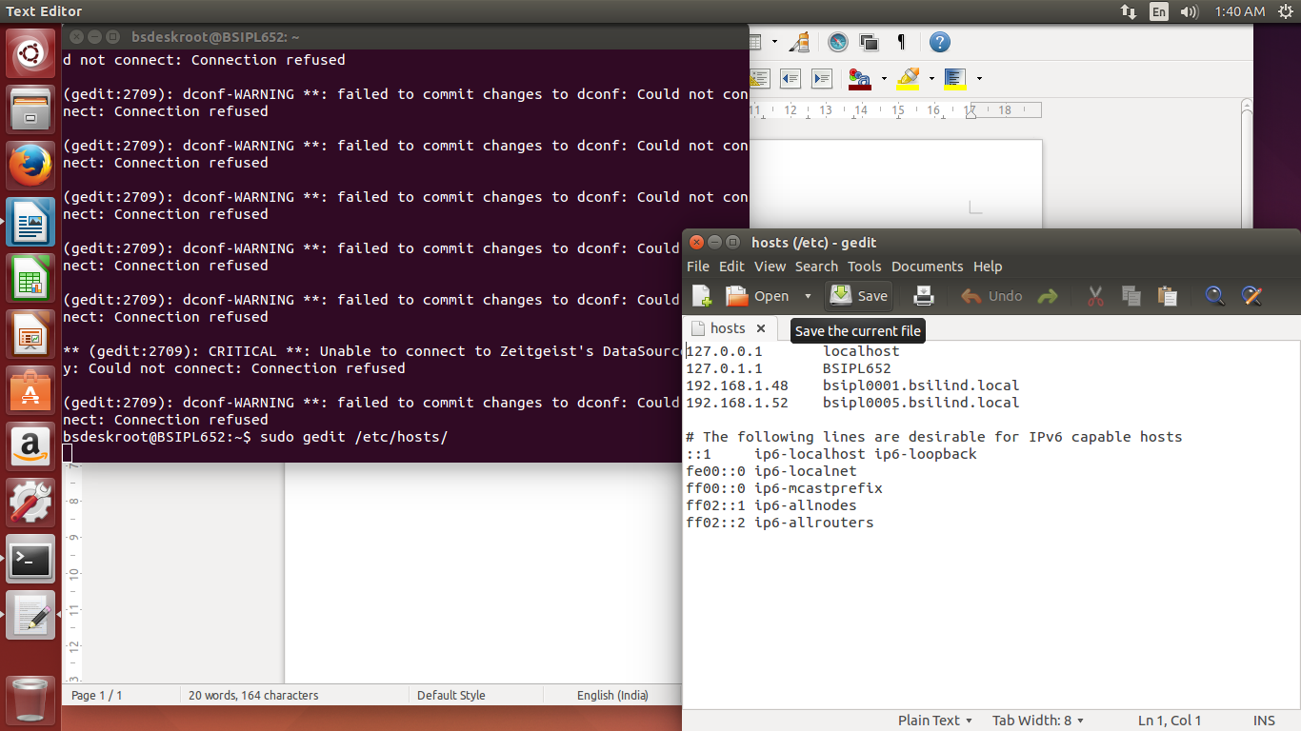
192.168.1.48 bsipl0001.bsilind.local

192.168.1.52 bsipl0005.bsilind.local

Step 2: sudo nano /etc/nsswitch.conf

#hosts: files mdns4_minimal [NOTFOUND=return] dns

hosts: files dns mdns4

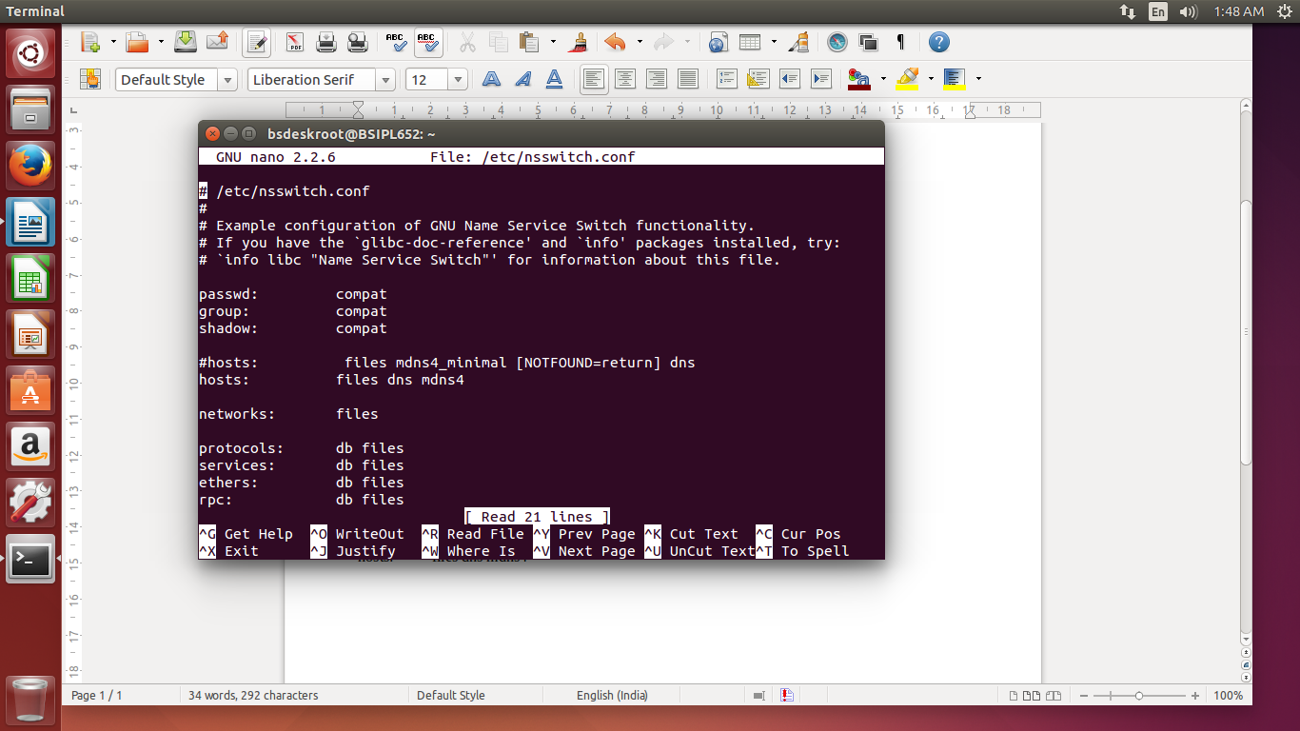

step3 : sudo nano /etc/resolv.conf

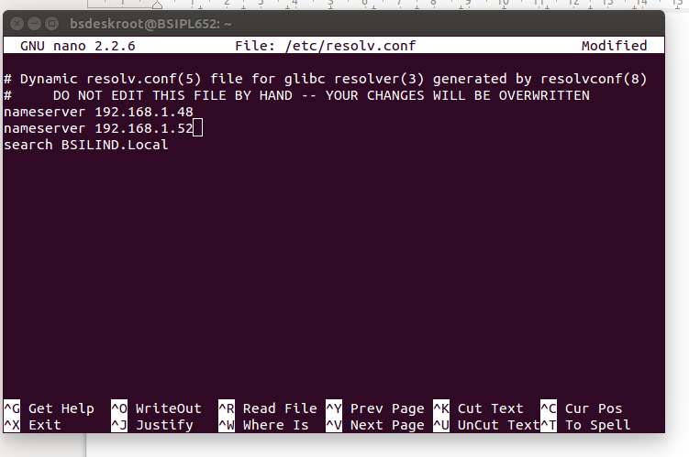

Step4:

a): sudo -s and login as root
b): download from the below URL

Go to the following address and download the most current version of PBIS:

http://download1.beyondtrust.com/Technical-Support/Downloads/PowerBroker-Identity-Services-Open-Edition/?Pass=True

Or, from a terminal type the following commands:

cd ~
sudo wget http://download.beyondtrust.com/PBISO/8.0.1/linux.deb.x64/pbis-open-8.0.1.2029.linux.x86_64.deb.sh

c):
sudo chmod a+x pbis-open-8.3.0.3287.linux.x86_64.deb.sh

d):
sudo ./pbis-open-8.3.0.3287.linux.x86_64.deb.sh

step5: type sudo

step6: To join your Ubuntu Desktop to the windows domain

cd /opt/pbis/bin/
sudo domainjoin-cli join --disable ssh bsilind.local bsilsrvid@bsilind.local

Step 7: Restart the system

Step 8: Set up the default configuration for domain users
a) Login as root by typing sudo -s
b) from the terminal type the below command

/opt/pbis/bin/config UserDomainPrefix bsilind
/opt/pbis/bin/config AssumeDefaultDomain true
/opt/pbis/bin/config LoginShellTemplate /bin/bash
/opt/pbis/bin/update-dns
/opt/pbis/bin/ad-cache –delete-all

Step 9: Type
sudo gedit /etc/pam.d/common-session in the terminal

a) Find the line that states the following:
session sufficient pam_lsass.so
b) Replace it with:
session [success=ok default=ignore] pam_lsass.so

Step 10: Give sudo access to users/groups
sudo gedit /etc/sudoers

# User privilege specification

root ALL=(ALL:ALL) ALL

# Members of the admin group may gain root privileges

%admin ALL=(ALL) ALL

%bsilind\\domain^Users ALL=(ALL:ALL) ALL

Step 11: Join Domain at start up
Create the file :
sudo nano /etc/init.d/domainjoin

#!/bin/bash

#Join Ubuntu Linux to Domain

i=0

while [ $i -lt 20 ]; do

sleep 1

is_up=$(ping -q -w 1 -c 1 `ip r | grep default | cut -d ' ' -f 3` > /dev/null && echo 1 || echo 0)

let i=$i+1

if [ $is_up -eq 1 ]; then

sudo domainjoin-cli join DOMAIN USER PASSWORD

let i=999

fi

done

save the file. Now

sudo chmod +x /etc/init.d/domainjoin

sudo update-rc.d domainjoin defaults

step 12:

sudo add-apt-repository ppa:lightdm-gtk-greeter-team/stable

sudo apt-get update

sudo apt-get install lightdm-gtk-greeter

sudo gedit /etc/lightdm/lightdm-gtk-greeter.conf

[greeter]
background=/usr/share/backgrounds/mate/nature/Blinds.jpg
theme-name=Ambiance
icon-thene-name=LoginIcons
default-user-image=/usr/share/pixmaps/griffon_icon.phg
font-name=Ubuntu 11
xft-antialias=true
xft-dpi=96
xft-hintstyle=slight
xft-rgba=rgb
show-language-selector=true
#indicators=~language;~session;~power

Step 13: Edit the below command from terminal as below

sudo gedit /usr/share/lightdm/lightdm.conf.d/50-unity-greeter.conf

greeter-session=lightdm-gtk-greeter

allow-guest=false

greeter-show-manual-login=true

#greeter-session=unity-greeter

Restart the system the check the domain user to Login

If the user not not having sudo privilege, follow the below steps

sudo gedit /etc/sudoers

#User privilege specification
root ALL=(ALL:ALL) ALL
e.g: support@bsilind.local ALL=(ALL:ALL) ALL
e.g: itrequest@bsilind.local ALL=(ALL:ALL) ALL

As root, run domainjoin-gui or domainjoin-cli to join a domain so you can log on

with Active Directory credentials. Example:

domainjoin-cli join MYDOMAIN.COM MyJoinAccount

JAVA Installation:

Using a PPA

You can use WebUpd8 PPA (this will download the required files from Oracle and install JDK 8):

sudo apt-add-repository ppa:webupd8team/java
sudo apt-get update
sudo apt-get install oracle-java8-installer
sudo apt-get install oracle-java7-installer

Are PPA's safe to add to my system and what are some “red flags” to watch out for?

Also ensure your JAVA_HOME variable has been set to:

/usr/lib/jvm/java-8-oracle

For this you can use the following command (see step 3 of Manual Install to see how to make it permanent):

export JAVA_HOME=/usr/lib/jvm/java-8-oracle

Setting Java environment variables

sudo apt-get install oracle-java7-set-default
sudo apt-get install oracle-java8-set-default

JAVA Manual install

The tar.gz provided by Oracle don't have an actual installation process. You just extract those files to a location you want and add them to your path. So the process is the following:

1. Download a .tar.gz from Oracle (here I will be using jdk-8u20-linux-x64.tar.gz);
2. Extract it to somewhere;

3. Move the extracted folder to /usr/lib/jvm. This is not required but it is the place where Java
runtime software is installed, and where tools like IDE's may search for it:

sudo mv /path/to/jdk1.8.0_20 /usr/lib/jvm/oracle_jdk8

4. Before addin this jdk as an alternative, you can see that the new alternative is not listed:

sudo update-alternatives --query java

sudo update-alternatives --query javac

5. Next, add the new jdk alternatives (2000 is the priority and feel free to pick a different number):

sudo update-alternatives --install /usr/bin/java java /usr/lib/jvm/oracle_jdk8/jre/bin/java 2000

sudo update-alternatives --install /usr/bin/javac javac /usr/lib/jvm/oracle_jdk8/bin/javac 2000

6. Now you should see the new jdk listed and you can switch between the alternatives with this command:

sudo update-alternatives --config java

sudo update-alternatives --config javac

7. Create a file /etc/profile.d/oraclejdk.sh with the following content (adapt the paths to reflect the path where you stored your JDK):

export J2SDKDIR=/usr/lib/jvm/oracle_jdk8
export J2REDIR=/usr/lib/jvm/oracle_jdk8/jre
export PATH=$PATH:/usr/lib/jvm/oracle_jdk8/bin:/usr/lib/jvm/oracle_jdk8/db/bin:/usr/lib/jvm/oracle_jdk8/jre/bin
export JAVA_HOME=/usr/lib/jvm/oracle_jdk8
export DERBY_HOME=/usr/lib/jvm/oracle_jdk8/db

Done! Those paths will only be recognized after you logout or restart, so if you want to use them right away run source /etc/profile.d/oraclejdk.sh.

SQuirrel SQL Client Installation
Download or

\\bsipl0011\g$\Apps\RandD Software\squirrel-sql-3.7-standard.jar

# java -jar squirrel-sql-3.3.0-install.jar

